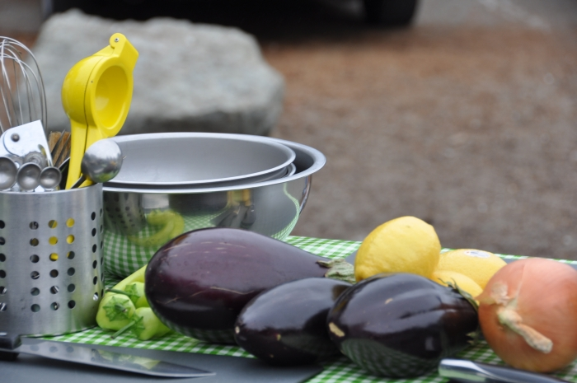

Mediterranean Feast at the Beach (hands-on)
with Oded Shakked of Longboard Vineyards

Sunday, October 3, 2010
2:00 - 5:00 PM
Doran Beach, Bodega Bay
$94 ($84 for Longboard Wine Club members)

Yes, Relish is roving back to the beach! We’ll be cooking up a feast of Mezze—appetizers and small plates inspired by the flavors of the Mediterranean, Israel and the Middle East. The charming Oded Shakked, winemaker at Longboard Vineyards, will share traditional Israeli recipes, from kabobs to pickles, hummus to zhoug. We’ll prep, cook and grill at Doran Beach in Bodega Bay, sipping wonderful Longboard wines along the way (of course!) Guests will learn traditional recipes for flavorful Israeli dishes influenced by the flavors of the Middle East, Northern Africa and Eastern Europe, and Oded will share stories about the foods and meals of his homeland. We’ll enjoy our Mezze feast as they do in Israel—the abundance of flavors on the table to be shared with friends.

- Dips with Pickled Summer Veggies
  - Grilled Handmade Pita Bread
  - Hummus
  - Tahini
  - Zhoug
  - Harissa
- Cucumber and Labaneh Cheese Salad
- Carrot Salad with Tumeric & Paprika
- Grilled Eggplant Salad
- Ground Lamb Shishkabob on Rosemary Skewers
- Chicken Shashlik (marinated chicken on skewers)

This Relish class includes 12 ounces of wine per person served to all participants over 21 years of age. Additional wine is available for purchase by the glass or bottle.

To register, please contact Relish Culinary.

Donna del Rey, Owner
Relish Culinary Adventures
http://www.relishculinary.com

